PROJECT REPORT
ON
Comparison between Various SDLC Models of AJIO.
Submitted to
NMAM INSTITUTE OF TECHNOLOGY, NITTE
(Off-Campus Centre, Nitte Deemed to be University, Nitte - 574 110, Karnataka, India)
In partial fulfilment of the requirements for the award of the
Degree of Bachelor of Technology
In
INFORMATION SCIENCE AND ENGINEERING
By
Amogh P Shetty NNM24IS021
Under the guidance of
Dr. Jason Elroy Martis, Associate Professor,
Department of Information Science and Technology,



Abstract
Extended Software Development Life Cycle Software development life cycle provides a graphical process chart, on which effective, maintainable and efficient software systems can be developed, with well-defined phases of it, such as the planning, requirement analysis, design, development, testing, deployment and maintenance. The SDLC model is a critical factor of choice when the e-commerce platform will be of large scale, scalability, security, agility and integration are important concerns. The paper addresses the importance of SDLC and operation and compares the models of development used like Waterfall, Incremental, Iterative, Spiral, and Agile.
The article then proceeds to address how SDLC models are applicable to AJIO that is among the most popular Indian online fashion stores via Reliance Retail. AJIO faces such technical and commercial threats as the capacity to handle volume user traffic in sales at festivals, data security requirements, prompt reaction to fashion and the capability of clearing huge networks of their supply chains. Fourth, the Waterfall and Incremental models are critically presented in terms of the functioning needs of AJIO. Whereas the Waterfall model is appropriate in the strict and inflexible backend systems, the Incremental model would be more effective in the dynamic updates to the feature of the system, as well, in the customer-driven change.
In this paper, various SDLC models including Waterfall, Incremental, Iterative, Spiral, and Agile will be analyses in order to establish the models that could work in AJIO business environment. Waterfall model is sequential and structured and thus applies well to stable backend systems and definite scope projects. Nevertheless, it is not that flexible in case of frequent updates or changes required by customers are needed. The Incremental model on the other hand gives the opportunity to develop and deliver the system in small functional amounts to enable faster releases, constant feedback, and simpler adaptability to market demands. This model is in line with the requirements of AJIO to have seasonal updates, regionalisation, and constant increase in features.
In addition, the analysis between these models brings out the need to balance stability and flexibility in large-scale software development. An adaptive or a hybrid method can be more effective, with some organized planning, and some improvements through trial and error.

TABLE OF CONTENTS:
1. Introduction
2. Introduction to Ajio and Its Business Context
3. Comparison of Waterfall, Incremental and Spiral Model of AJIO.
4. Incremental Model
5. Spiral Model
6. Comparison of the models
7. Preferred Model with respect to Ajio
8. AJIO functional and Non-functional requirements of AJIO
9. Impact of SDLC models on the time and costs in AJIO
10. Requirements Validation
11. Conclusion
12. References
13. GITHUB Repo Link

- Introduction

- What is SDLC:
SDLC is the methodological approach to develop the software by the use of its various stages such as planning and development and testing and deployment. An appropriate SDLC model must be selected in order to attain improved project success in executing large-scale systems specifically in the case of Flipkart that works as a major e-commerce platform across India. The SDLC life cycle is an effort to develop reliable maintain able software systems to meet the user requirements. Software engineering requires the SDLC model that develops time-planned specifications through which all parts of the software development can function efficiently to develop software within their allocated time and specifications as outlined by the user.

- Why is SDLC Important:
Software development becomes a tough task since requirements change as technology as well as various functional groups must collaborate. It is through the SDLC methodology where successive organizations with its distinctive management framework can deliver throughout all phases of their software development. The result of such coordination is that the stakeholders both come up with a common ground regarding the requirements of software development as they also develop their route towards these destinations. Some benefits of SDLC:
• Greater publicity of the development process to all stakeholders.
• Effective estimation, planning and scheduling.
• Better risk management and estimation of expenses.
• Deployment of systems with less repetition and increased customer satisfaction.

- How does SDLC work:
It performs multiple tasks that are involved in developing a software application. The creation process becomes divided into several phases, which developers fill with the implementation of new features and software bugs fixes.

Stage 1- Planning and Requirements Analysis.
A need to acquire the most competent engineers comes out as an inevitable requirement at the initial stages of software development life cycle. By meeting the needs of clients, the app development team will have the potential to build reliable infrastructure upon which future software development stages can be reached. This phase has the number of key steps. This preliminary analysis conducted by members of the project team will result in the identification of client goals and problems. Upon the completion of the process of evaluation, which the team develops, various solutions options are generated and each option is allocated a cost estimate.
Stage 2 - Requirements definition.
The process of software development life cycle proceeds with an in-depth analysis of the requirements, which follows the selection of a software solution by the client. The team examines papers concerning the project, analyses the existing ecosystem of the client. It is among the software development life cycle steps that others view as transitional whereby it is done concurrently with planning and requirements analysis.
Stage 3 - Product Architecture Design.
After analyses the needs of the client properly on the past stage of software development life cycle, the developers develop a number of product architectures and present them to the client.
The final architecture is then developed on a Design Document Specification (DDS) and analysed by all parties through fineness, operational consistency, generalisability and cost-effectiveness. It is based on this architecture that any further software development life cycle steps and the software product concerned become rooted.
Stage 4 - The Product Development.
This is one of the most important stages in the software development life cycle which tries to generate working code and demonstrate results to the client. Most of the time is taken by the development in any project. The project usually takes more time than it was originally planned: during the development process, the client may have a new idea to be included in the project scope. According to certain SDLC models, the product may be modified during the development.

Stage 5 - Testing the Product.
Once all preparations to the last phases of software development life cycle are done, the quality assurance engineers begin to scout bugs. The other important step in SDLC life cycle phases is testing since it enables correction of problematic issues before they can result in problematic losses.
Although testing processes can be mentioned in other phases of the software development life cycle, being an independent one, testing presents an in-depth map of failures that should be corrected.
Stage 6 - Deployment and Maintenance.
Once the product is ready as release-ready, the second step in the chronological sequence of steps in software development life cycle is to present the completed software solution to the client.
The client may order the general product maintenance to resolve various problems to ensure the correct operation of the complete digital solution in future, once all SDLC life cycle activities are completed.

SDCL model presents an organized display of SDLC concepts to be implemented by organizations required to execute it. Various development projects have different chronological order in which their SDLC clauses are carried out in order to ensure the development process is optimized. This part gives a discussion on a number of SDLC models. The Different Models are,
• Waterfall Model.
• Incremental development Model.
• Iterative Model.
• Spiral Model.
• Agile Model.

- Introduction to Ajio and Its Business Context

- Overview of Ajio.
Reliance Retail subsidiary created the online retail company in 2016. The company can serve their clients with the help of fashion, and the categories of accessory and the lifestyle products. The site allows clients to do their shopping online with the use of the omnichannel capabilities that feature Ajio Street stores. It provides AI recognition and local parcel delivery functions with other AR applications to virtual product inspection.

- Technical and Marketing Strains.
• Scalability: 10 million+ users every month during the sales period during the festivals.
• Security: User data protection (PCI- DSS payment compliance).
• Nimbleness: Quick adjustment to the fashion and local tastes.
• Integration: Aligning with the supply system, Jio platforms, and logistics partners of Reliance.

- Comparison of Waterfall, Incremental and Spiral Model of AJIO.
1.Waterfall Model
Under Waterfall model, software development goes through steps that must be completed sequentially with the designers having to complete a step before commencing with the next step. The Waterfall model has very specific opportunities and limitations to the usage of this model in the massive online commerce platform belonging to Reliance Retail that is run under the brand Ajio. The following discussions offer a detailed discussion of how the Waterfall model would be applied in Ajio operations based on its prevailing challenges and business needs.
There are several points of suitability considering the context of AJIO:
At Ajio, the operations consist of stable backend systems and dynamic frontend features comprising inventory sync and order processing and AI recommendations with AR try-ons. The Waterfall model is suitable to the already predetermined projects of Ajio that have low risk factors but they are weak when it comes to agile customer-driven solutions.
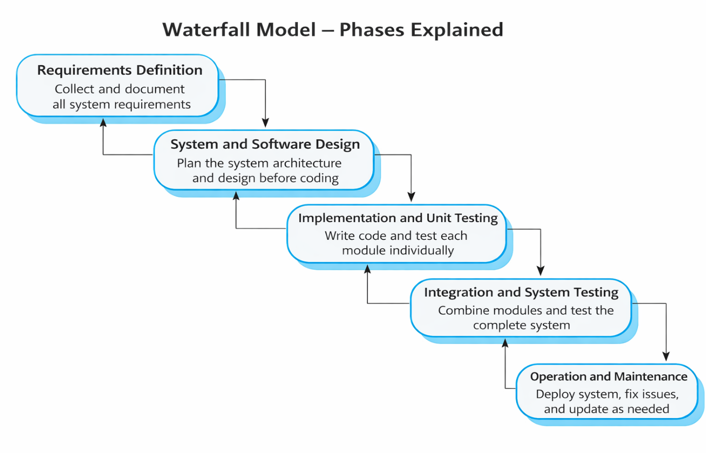

- Incremental Model

The Incremental Development Model is a Software Development Lifecycle technique to develop software by use of small incremental developments that provides components of the anticipated product features. In the incremental approach, system developers design, implement and test a design following each increment, and release it. The method introduces a block after the other towards the full system. The Incremental Development Model offers excellent project solution as it gives association between a purposeful planning and the continuous feedback cycle.
The e-commerce services offered by Ajio within the Indian markets are dynamic in nature, that is between customer demands and technical needs. Incremental model is an ideal model that can suit the needs of Ajio to: Kids Company expedites product launches especially when changing seasonal styles. The firm needs to change its products to suit the preferences of various regional customers by offering ethnic clothes of such festivals.

Incremental Model:

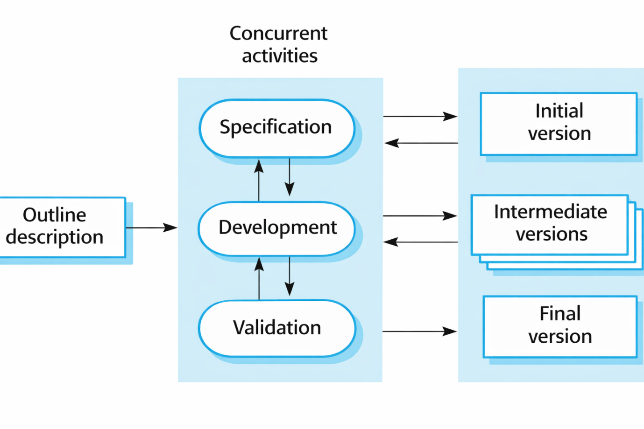
- Spiral Model

The Spiral Model is an iterative SDLC framework that focuses on risk. It combines key aspects of Waterfall, prototyping, and Agile methods. This model works well for Ajio, which operates under Reliance Retail as an e-commerce platform. It is ideal for managing risky projects that involve complex uncertainties. This document looks at the Spiral Model's structure for Ajio’s business, focusing on operational implementation, strategic goals, and organizational challenges.
Suitability:
Ajio faces tough competition in e-commerce. It needs quick innovation through tools like AR try-ons and hyperlocal delivery. At the same time, it must manage risks related to cybersecurity and scalability. The Spiral Model fits Ajio’s business needs by supporting high-priority projects. For instance, the company is building infrastructure to handle sales for 10 million users during holidays. Ajio uses AI-driven recommendations and blockchain technology for better supply chain transparency. It must find the right balance between quick operations and system reliability by ensuring that Jio platforms maintain a 99.9% uptime performance standard.

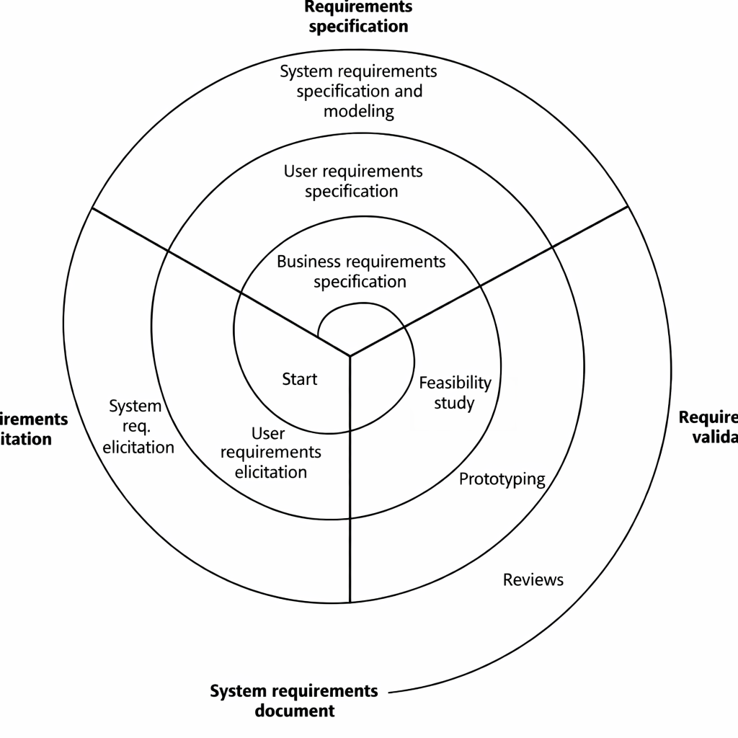

- Comparison of the models:

Aspect | Waterfall | Incremental | Spiral
Requirements | Fixed, stable (e.g., compliance modules). | Modular, evolving (e.g., UI/UX updates). | Risk-driven (e.g., cybersecurity upgrades).
Risk Management | Reactive (testing at the end). | Moderate (per-increment testing). | Proactive (iterative prototyping).
Cost Efficiency | High for fixed-scope projects. | Moderate (phased funding). | High long-term ROI for risk mitigation.
Ajio’s aspect | Backend systems, compliance. | Feature rollouts (e.g., hyperlocal delivery). | High-risk R&D (e.g., AI/ML projects).

- Preferred Model with respect to Ajio
It is preferred to use the hybrid model including both spiral and incremental model.
Strategy:
High-risk innovations such as blockchain loyalty programs should use Spiral as their development model. Regular Feature releases utilise the combination of Incremental and Hybrid SDLC design for implementing new features. This method works well with introducing regional language capabilities.

Why incremental development model:

- Early Risk Identification: The approach of developing projects incrementally enables you to manage risks through smaller segments which produces less overall project danger.
- Faster Feedback Loops: The product development process shows partial deliverables to stakeholders and end-users thus enabling their continuous feedback to help the final product match their required specifications.
- Flexibility to Accommodate Changes: The hybrid approach combines traditional planning systems from the traditional model with agile flexibility because of its adaptability for changes. The incremental delivery system helps organizations smoothly transition new demands and changing project needs.
- Better Resource Management: Small divisions within a project enable teams to distribute resources better while tracking progress along with making essential plan modifications.

Why spiral model:
- Risk-driven Development: Risk analysis takes place during each spiral iteration to uncover potential problems which can be properly addressed before receiving larger scope.
- Adaptability to Changing Requirements: The periodic review process grants stakeholders a chance to direct requirement modifications which therefore simplifies project adjustments throughout development.
- Enhanced Stakeholder Involvement: The stakeholder involvement achieves greater enhancement through empirical reviews performed at spiral phase termination points that enable organization requirement maintenance.
- Incorporation of Prototyping: Each development cycle requires prototyping as a fundamental component to permit teams to validate their concepts and make important design decisions right from the start in hybrid work environments.

- AJIO functional and Non-functional requirements of AJIO

- Functional requirements
Functional requirements are business operations and system features that a system requires to perform effectively to meet its requirements. The AJIO functional specifications are designed to provide all the system users such as vendors and administrators with easy processes of online shopping.
User Registration & Authentication: The users are able to authenticate by undergoing account creation and profile customization as well as to verify their registration by using various methods of access. Such features as a password recovery feature and a social media feature allowing integration.
Profile Management: Change personal data including the name and address along with the contact information. The profile provides the decision-makers with control over the payment options they store and their account preferences.
Search/ Filters: Search by key-word using auto-suggestions. Products are ordered by the users of the site by filtering the available categories of products (ethnic wear and accessories), ranges and sizes of prices and a list of brands or a customer rating based on their evaluation.
Light Product Catalog: The light page of a product containing an overview product description, video, images, and customer rating. Customers should also be able to view supply status as well as delivery timing of goods.
Cart Management: Consumers are able to add and delete items in their cart and increase or decrease the quantity of items and save to be used in the future. The customers would be able to avail promotion codes alongside coupons and vouchers found at Jio Mart.
Returns & Refunds: This will allow a customer to initiate a return or an exchange within the given time. The system automatically carries out refunds using the same means by which the customers initially made payments.
Safe Processing: PCI-DSS payment processing. End to end sensitive data encryption is where the system secures all the details between start- up to termination.
Mobile and cross-platform compatibility: the responsive design system allows the smooth running of web applications to mobile applications since it supports mobile and cross-platform compatibility. Unified user experience irrespective of the platform.

- Non-functional requirements
The non-functional requirements determine system qualities that assure efficiency alongside the security and usability. These are significant system attributes, which are directly related to the performance of the company, as well as its reliability and scalability.
Scalability: The system should have capability to accommodate millions of users and volumes of transactions and heavy traffic requirements during the periods of discounts during festive season.
Security: To promote fraud defenses and data security, companies are to implement encryption, and multi-factor authentication along with fraud detection software to discourage unauthorized breach of data and information.
Performance: To have a smooth shopping experience it is assumed that AJIO should have a high-page loading rate coupled with low turnaround time and high optimization of search results.
Availability: The platform has to have uptime of 99.99 in order to have round-the-clock operations since downtime would lead to losses in the form of finances as well as loss of customer satisfaction.
Usability: The platform must have a user interface in addition to offering easy navigation and receptive interactions on desktops and smartphones alongside tablets.
• Compliance AJIO should comply with the regulations of the system laws concerning data privacy according to GDPR and secure payment processing according to PCI DSS in order to ensure the customer information security.
• Maintainability- The system architecture must be designed in a modular design style that will enable the updates, bug fixes and enhancements to be made without affecting the entire platform.

- Impact of SDLC models on the time and costs in AJIO.

- Waterfall Model: Cost is reduced in the beginning but high re-work because of late testing and re-slow releases of features.

- Incremental Model: Cost sharing based on time; more rapid releases, which is cost-effective.

- Spiral Model: This model is costly to undertake a lot of risk management operations that aids in avoiding failings that will cause failures that may cause long term costs.

The evaluation shows that AJIO should use an integration of the Incremental model with the Spiral model. A continuous update capability and rapid market deployment become possible through the Incremental model due to its characteristics. This proves beneficial for developing evolving e-commerce platforms. Production utilizing the Spiral model enables successful security controls and scalability together with risk management which are essential for executing large financial processes and serving changing customer needs. AJIO will preserve its market agility and security while remaining competitive through implementation of these two development models together.

- Requirements Validation

Requirement’s validation is nothing but making sure that all the requirements are in agreement with the stakeholder’s requests. In other words, it is about checking if the requirements are complete, consistent, and correct.
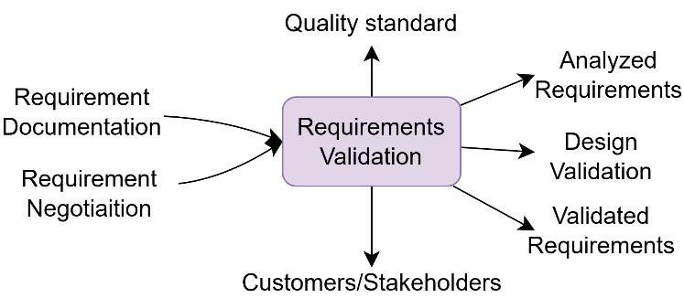

Requirement validation Strategy.

Requirements validation is what is needed to make sure the system created by AJIO is designed to meet the business requirements prior to the mass development. The key strategies include:
• Stakeholder Review: Feedback through customers, sellers and administrators.
• Prototyping With the aim of validating the develop EMUI and interactive demonstrations.
• Requirement Traceability Matrix (RTM): This makes sure that every requirement is connected to a deliverable.

- Automated Testing and Verification: To check the compliance of requirements, it is necessary to run test cases.
- User Acceptance Testing (UAT): Carrying out real life trials with some select users.

Problems in Requirements Validation:

• Altering Business Requirement: The trends of e-commerce change swiftly and that is why the requirement should be modified constantly.
• Various Stakeholder Requirement: It may be difficult to strike a balance between various user requirements.
• Scalability Failures: Making sure that there are no new features that impact the performance at scale.
• Security & Compliance: Checking security policies against emerging cyberattacks.

Incorporating Incremental model and Spiral model at the same time, AJIO has certainty in checking the requirement of the system and flexibility in adapting to the needs of the market.

- Conclusion

The situation analysis of AJIO needs indicates that it has a holistic platform that is considerably responsive to the needs of its diverse userbase. The key functionalities that have been envisaged in AJIO include detailed product lists, efficient search and filtering tools, secure checkout tools and active order management. All these characteristics make sure that the site is not only satisfying the demands of the customers, but is also engaging, efficient and experience during the shopping process. The elaborated functional requirements facilitate smooth communications leading to increased customer satisfaction and retention.
Dubbing the functional part, the non-functional ones stress the idea that AJIO is committed towards performance, security, and scalability. The site will be capable of supporting large amounts of traffic and fast responses which makes it reliable even during the peak times such as sales or promotion. Having a strong security, adherence to industry best practices, emphasis on accessibility, and maintainability, AJIO is highly equipped to provide an insecure and stable environment to its users. Such concern on the non-functional factors makes sure that the entire system can be effective, versatile and enduring in the long run.
Finally, AJIO requirements elicitation process is important in the field of fitting the technical development to market expectations and customer expectations. With the combination of interviews with stakeholders, focus groups, surveys, market research and usability testing, the development team can get the overall understanding of the current and emerging needs. Such a methodical way of developing the platform does not only enable the development of a platform with a range of features but also makes the design responsive to the ever-changing environment of e-commerce, eventually making AJIO poised to a sustainable growth and success.

- References

- Sommerville, I. (2015). Software Engineering (10th ed.). Pearson.
- Pressman, R. S. (2019). Software Engineering: A Practitioner's Approach (9th ed.). McGraw-Hill.
- IEEE Computer Society. (1998). IEEE Recommended Practice for Software Requirements Specifications (IEEE Std 830-1998).
- Boehm, B. W. (1988)
- Larman, C., & Basili, V. R. (2003)
- Royce, W. W. (1970)
- Reliance Retail Limited (2024)
- PCI Security Standards Council (2024)
- European Parliament and Council (2016)
- ISO/IEC (2018)
- Beck, K., et al. (2001)

- GITHUB Repo Link
Github Repository: https://github.com/amoghpshetty/SDLC-ON-AJIO

